**NATIONAL ENGINEERING COLLEGE K.R.NAGAR, KOVILPATTI- 628503**

**Department Of Computer Science and Engineering**

**19CS30E – ADVANCED JAVA PROGRAMMING**

**Mini Project Report**

**ONLINE SHOPPING SYSTEM USING JSP**



**SUBMITTED BY**

**B Sahanna - 2112084**

**S Dimple Abirami - 2112071**

**K Amutha Priya - 2112115**

**TABLE OF CONTENTS**

| 1. **Abstract** 2. **Introduction**   **2.1 Project Objective**  **2.2 Project Overview**  **2.3 Project Scope**  **2.4 Technology Stack**   1. **Modules**   **3.1 Login module**  **3.2 Signup module**  **3.3 Dashboard**  **3.4 Products**  **3.5 Add to Cart**  **3.6 Order**   1. **System Design**   **4.1 Input and Output Design**  **4.2 Database**  **4.3 Frontend**  **4.4 Backend**  **4.5 Tables**     1. **Screenshots** 2. **Source Code** 3. **Conclusion** 4. **References** |
| --- |

# 

# **ABSTRACT**

This project aims to develop a web-based shopping system for an existing shop and subsequently deliver it as a web application using java. The primary objective of this project is to extend the benefits of online shopping to the customers of the physical store. It allows customers to purchase products from the shop conveniently using their Android devices via the internet, with the added convenience of home delivery from their favorite shop. This system can be customized for use in local stores or even for multinational branded shops with retail outlet chains.

By offering an online portal where customers can easily shop from anywhere, traditional shops can retain their customer base and compete with popular online marketplaces such as Flipkart or Amazon.

**INTRODUCTION**

**Project Objective :**

The objective of the project is to make a web application in Netbeans platform to purchase items in an existing shop using jsp. In order to build such an application complete web support needs to be provided. A complete and efficient web application which can provide the online shopping experience is the basic objective of the project

**Project Overview:**

The central concept of the web application is to allow the customer to shop virtually using the Internet and allow customers to buy the items and articles of their desire from the store. They can browse the required category of the product, then add the required product to the cart and make the payment process.

**Project Scope :**

This system can be implemented to any shop in the locality or to multinational branded shops having retail outlet chains. The system recommends a facility to accept the orders 24*7 and a home delivery system which can make customers happy.

If shops are providing an online portal where their customers can enjoy easy shopping from anywhere, the shops won’t be losing any more customers to the trending online shops such as flipkart or ebay. Since the application is available in the Smartphone it is easily accessible and always available.

**Technology Stack :**

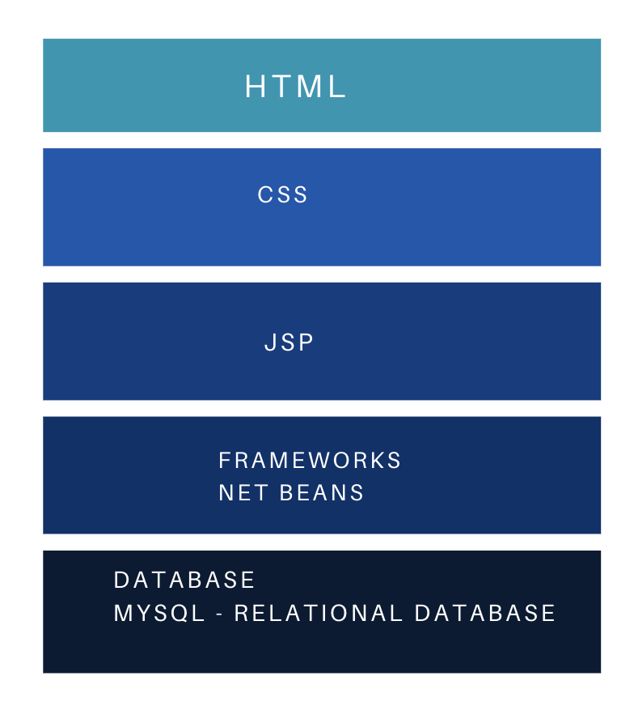

**MODULES**

The modules present in the project include the following

* + Login module
  + Signup module
  + Dashboard
  + Products
  + Add to Cart
  + Order

**Login Module :**

This module is used to read the username and password from the user and check it with the existing database table which has been created in the name of the user while signup and permit the login if both the credentials match

**Signup Module :**

This module is used to create a new database table with the username and map it with email, password and contact number. It reads the username, password, email, and contact number of the user as the input.

**Dashboard :**

This module is used to display the homepage of the onlineShopping system named “LUXCART”. The navigation bar contains elements like home, collection, specials, blogs, about us, products and add to cart icon.

We have divided the design of the homepage into sections that while clicking the elements in the nav bar a particular section is navigated. The add to cart symbol takes the user to the page where the items that are added to the cart are displayed.The products like shoes, shirts, frocks, glasses,etc are displayed as drop down box. By clicking the particular item the respective page is displayed.

**Products :**

The products like shoes, shirts, bottles, toys, frocks, glasses, jewelry etc.. were displayed and on clicking the name of the product in the dropdown list the respective products jsp file opens with the products details like name , image and price with an add to cart button which is used to add the required item to the cart.

**Add to Cart :**

The addtocart.jsp file is used to display the items along with the prices that have been added to the cart. It shows the total price of the products and the order now button to place the order.

**Order :**

The order has been placed by pressing the order now button on the add to cart window.Then a new page appears that approves and places the order and the expected date of delivery is displayed.

**SYSTEM DESIGN**

System design is the solution for the creation of a new system. This phase focuses on the detailed implementation of the feasible system. It emphasizes translating design. Specifications to performance specification. System design has two phases of development

* Logical design
* Physical design

During the logical design phase the analyst describes inputs (sources), outputs(destinations), databases (data sores) and procedures (data flows) all in a format that meets the user requirements. The analyst also specifies the needs of the user at a level that virtually determines the information flow in and out of the system and the data resources. Here the logical design is done through data flow diagrams and database design. The physical design is followed by physical design or coding. Physical design produces the working system by defining the design specifications, which specify exactly what the candidate system must do. The programmers write the necessary programs that accept input from the user, perform necessary processing on accepted data and produce the required report on a hard copy or display it on the screen.

**Input Design :**

Input design is the link that ties the information system into the world of its users. The input design involves determining the inputs, validating the data, minimizing the data entry and providing a multi-user facility. Inaccurate inputs are the most common cause of errors in data processing. Errors entered by the data entry operators can be controlled by input design. The user-originated inputs are converted to a computer based format in the input design. Input data are collected and organized into groups of similar data. Once identified, the appropriate input media are selected for processing. All the input data are validated and if any data violates any conditions, the user is warned by a message. If the data satisfies all the conditions, it is transferred to the appropriate tables in the database. In this project the student details are to be entered at the time of registration. A page is designed for this purpose which is user friendly and easy to use. The design is done such that users get appropriate messages when exceptions occur.

**Output Design :**

Computer output is the most important and direct source of information to the user. Output design is a very important phase since the output needs to be in an efficient manner. Efficient and intelligible output design improves the system relationship with the user and helps in decision making. Allowing the user to view the sample screen is important because the user is the ultimate judge of the quality of output. The output module of this system is the selected notifications.

**Database Design :**

Databases are the storehouses of data used in the software systems. The data is stored in tables inside the database. Several tables are created for the manipulation of the data for the system. Two essential settings for a database are

* Primary Key - the field that is unique for all the record occurrences.
* Foreign Key - the field used to set relations between tables.

Normalization is a technique to avoid redundancy in the tables.

**Frontend Design :**

JSP, HTML, CSS are utilized to implement the frontend.

**Java Server Pages (JSP)**

Different pages in the applications are designed using jsp. A Java Server Pages component is a type of Java servlet that is designed to fulfill the role of a user interface for a Java web application. Web developers write JSPs as text files that combine HTML or XHTML code, XML elements, and embedded JSP actions and commands. Using JSP, one can collect input from users through a web page.

**HTML (Hyper Text Markup Language)**

HTML is a syntax used to format a text document on the web.

**CSS (Cascading Style Sheets)**

CSS is a style sheet language used for describing the look and formatting of a document written in a markup language.

**Backend Design :**

The back end is implemented using MySQL which is used to design the databases.

**MySQL**

MySQL is the world's second most widely used open-source relational database management system (RDBMS). The SQL phrase stands for Structured Query Language.

**TABLES**

A table is created for storing the user details. It stores the username, password, mobile number, and email id of the users.

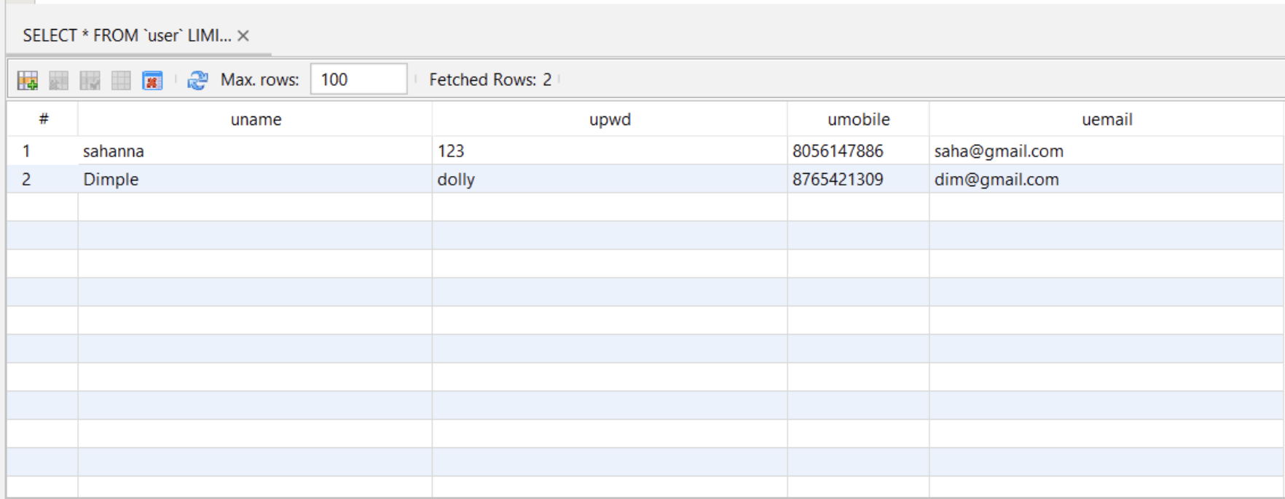

A table is created for each user with the table name as their username and it stores the productname (pname), price, and delivery date(del_date).

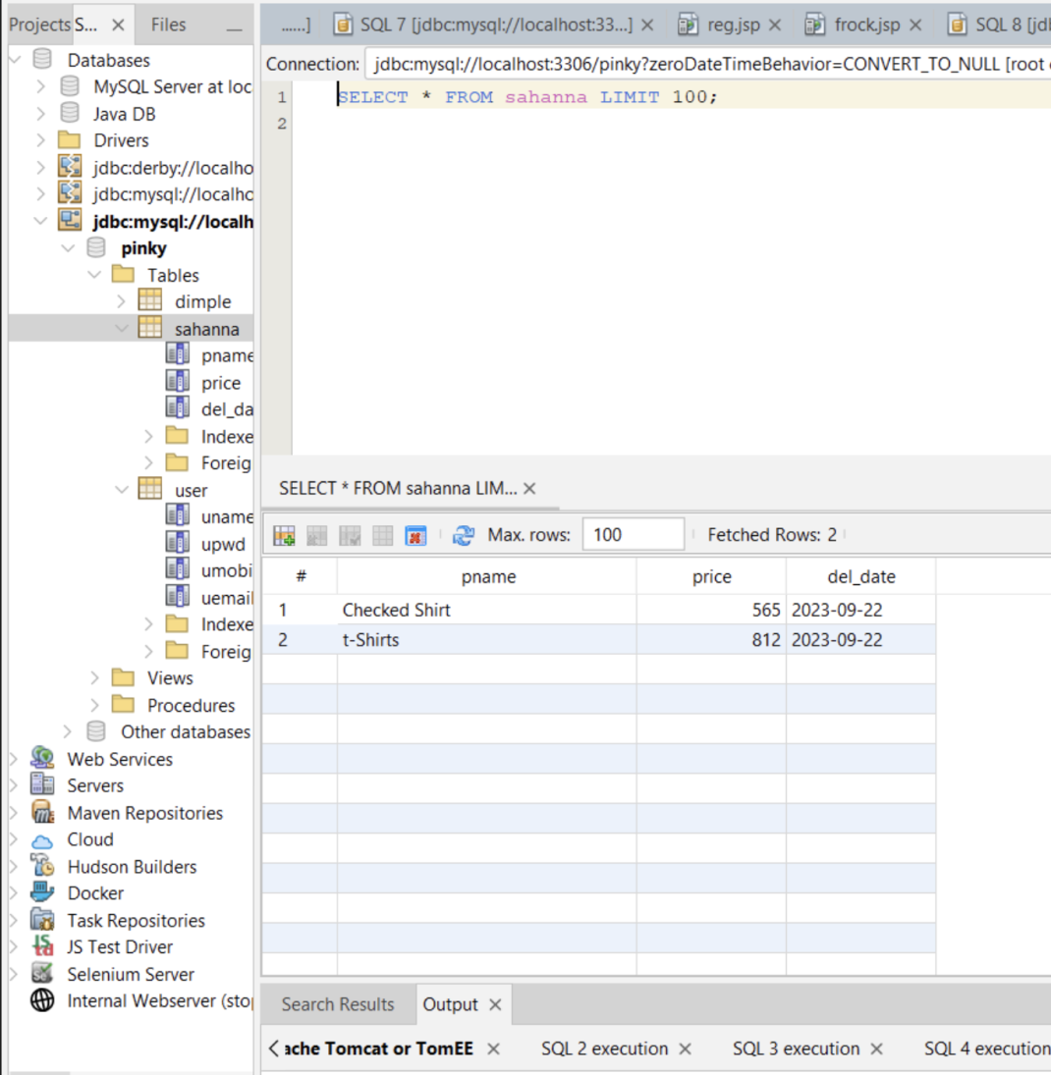

**SCREENSHOTS**

**Sign in Page :**

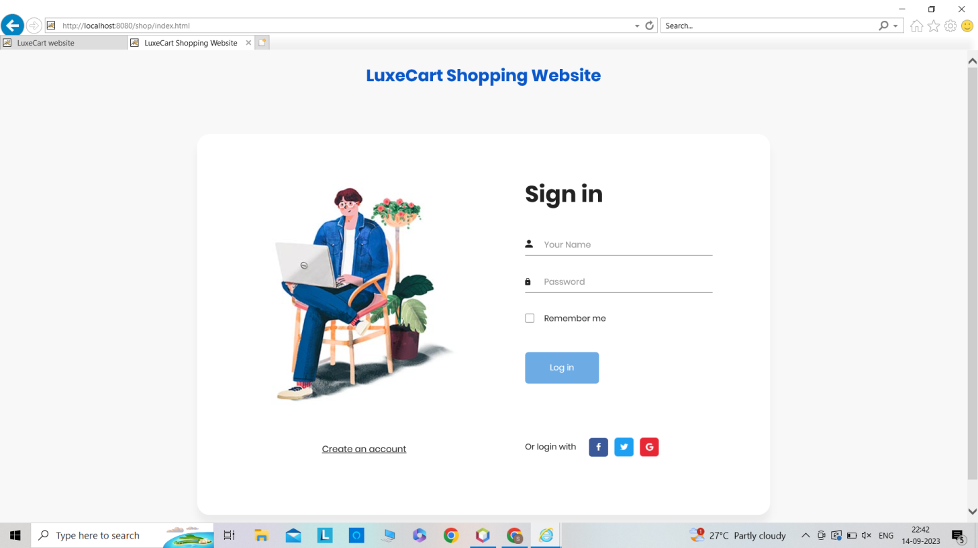

**Sign Up Page:**

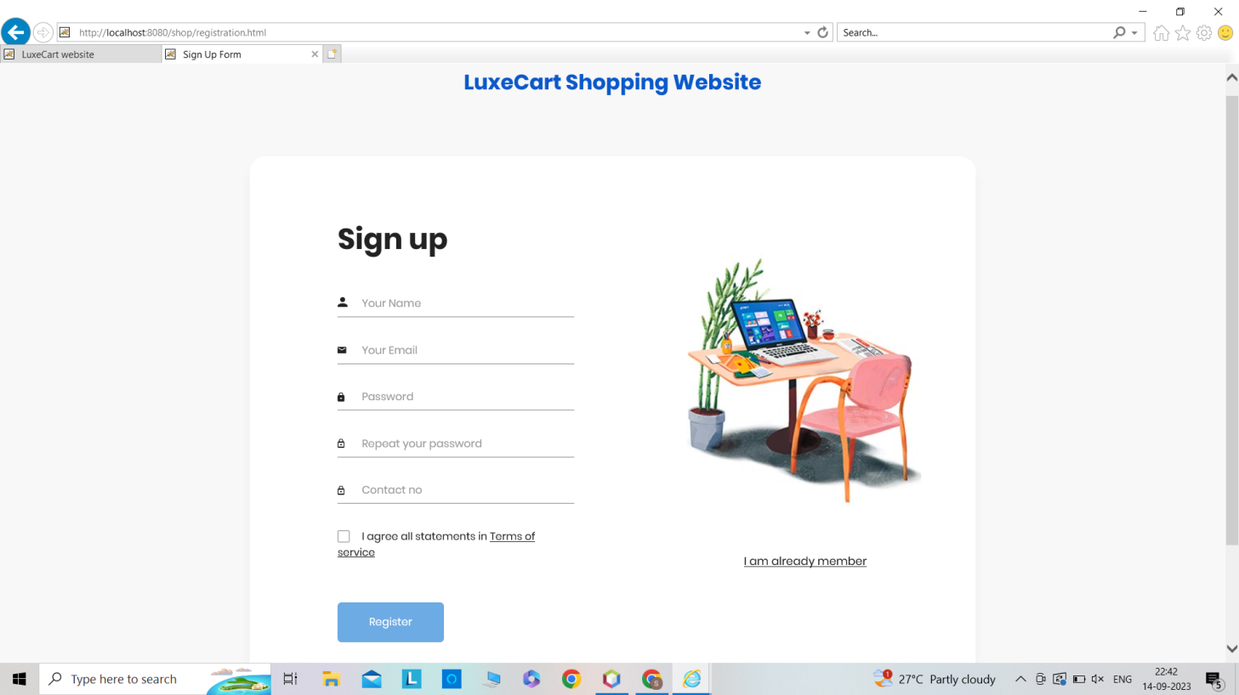

**Dashboard :**

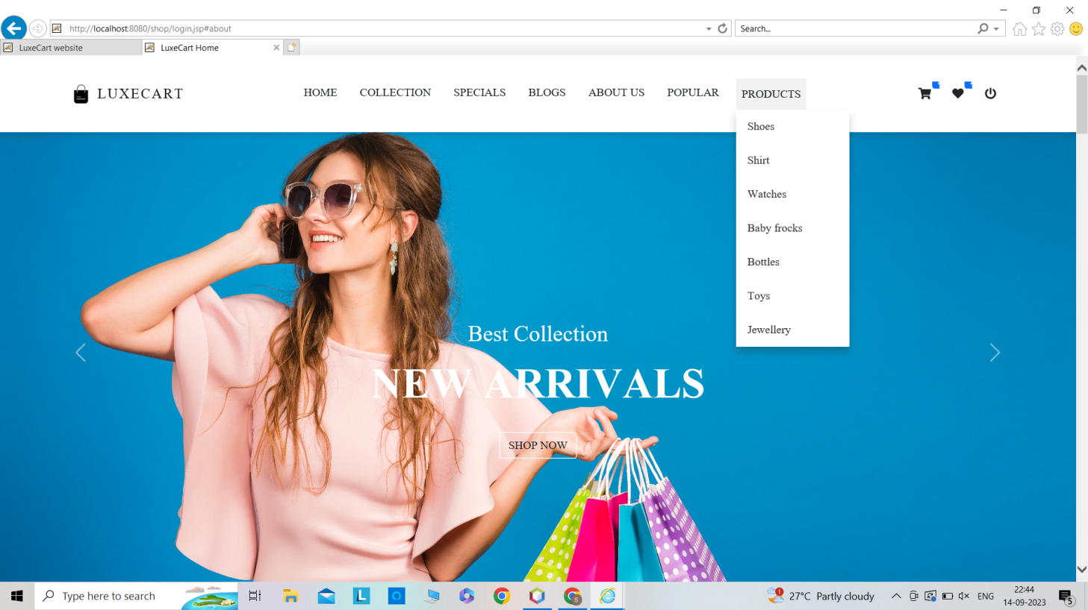

**Collections :**

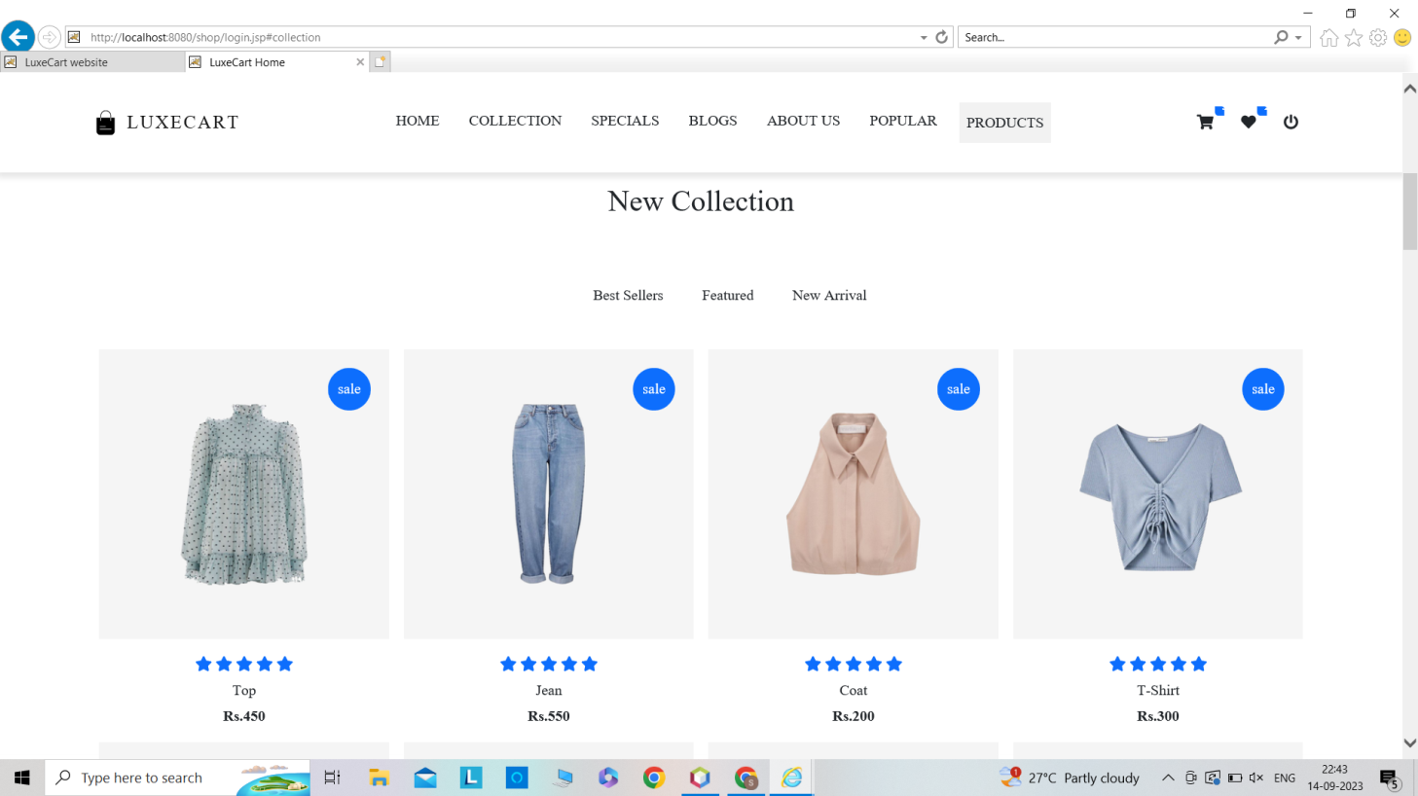

**Specials :**

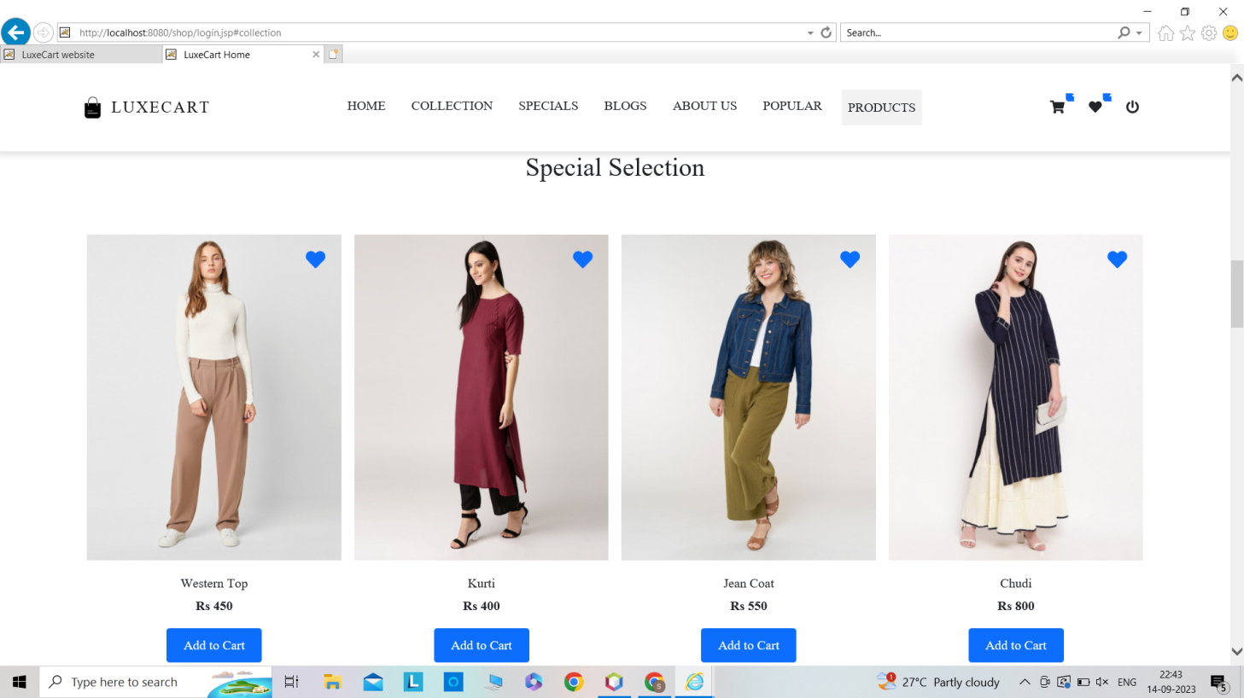

**Popular :**

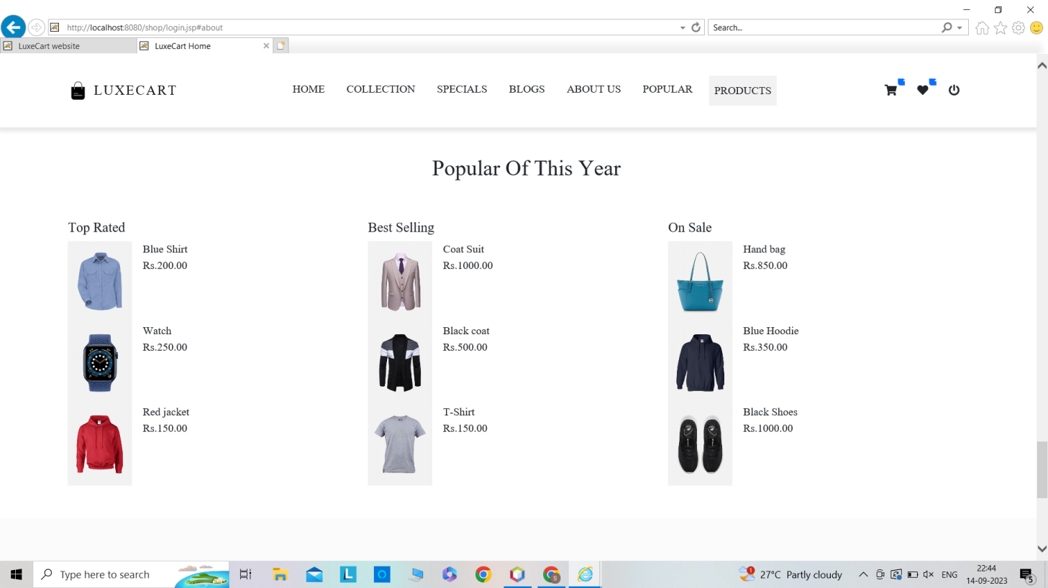

**About Us :**

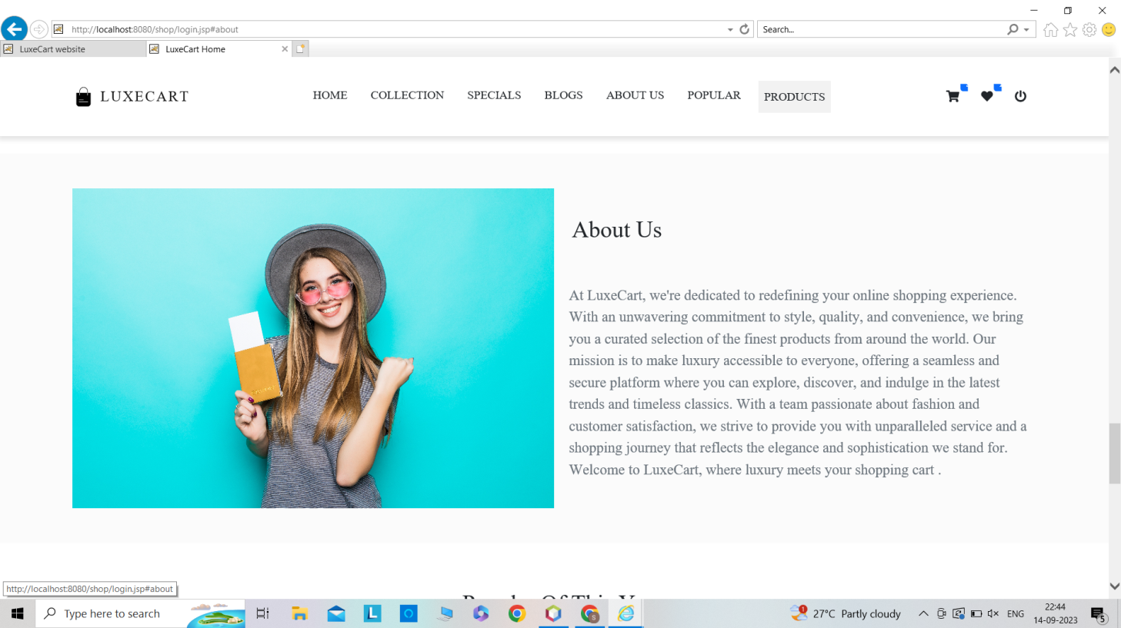

**Blogs :**

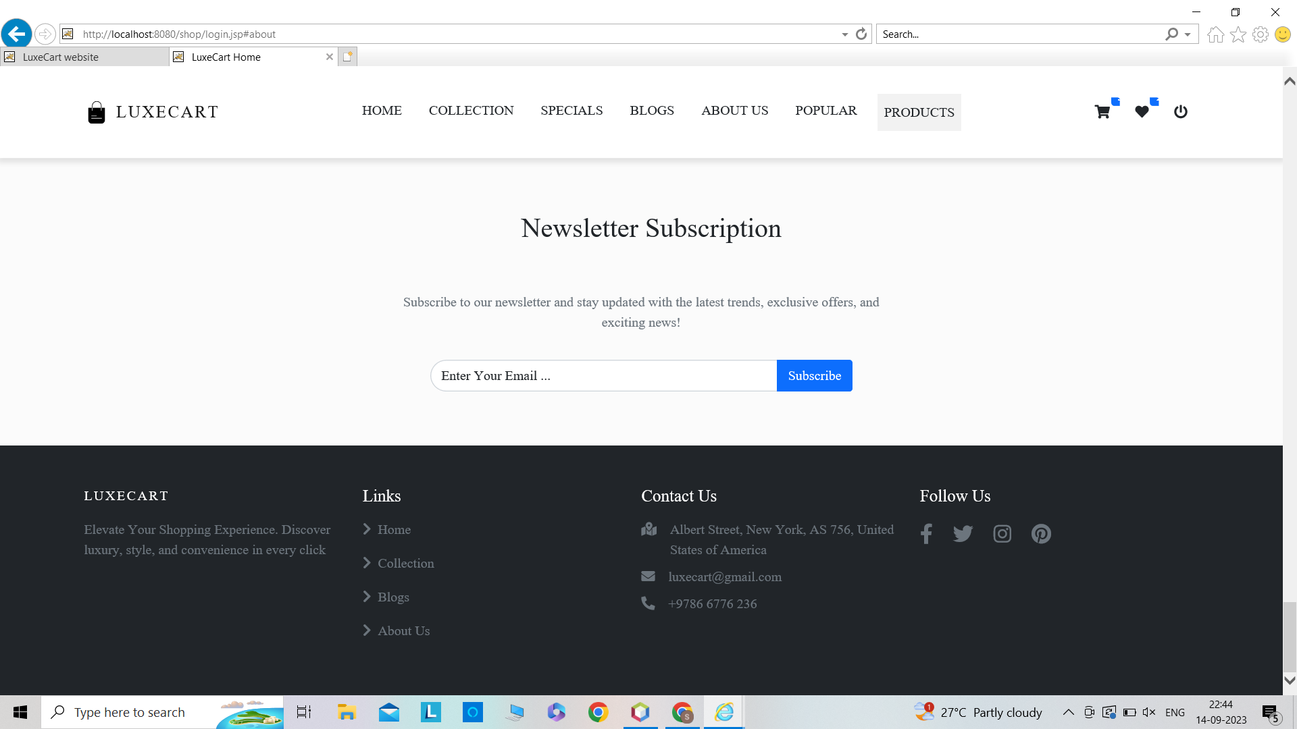

**PRODUCTS**

**Frocks :**

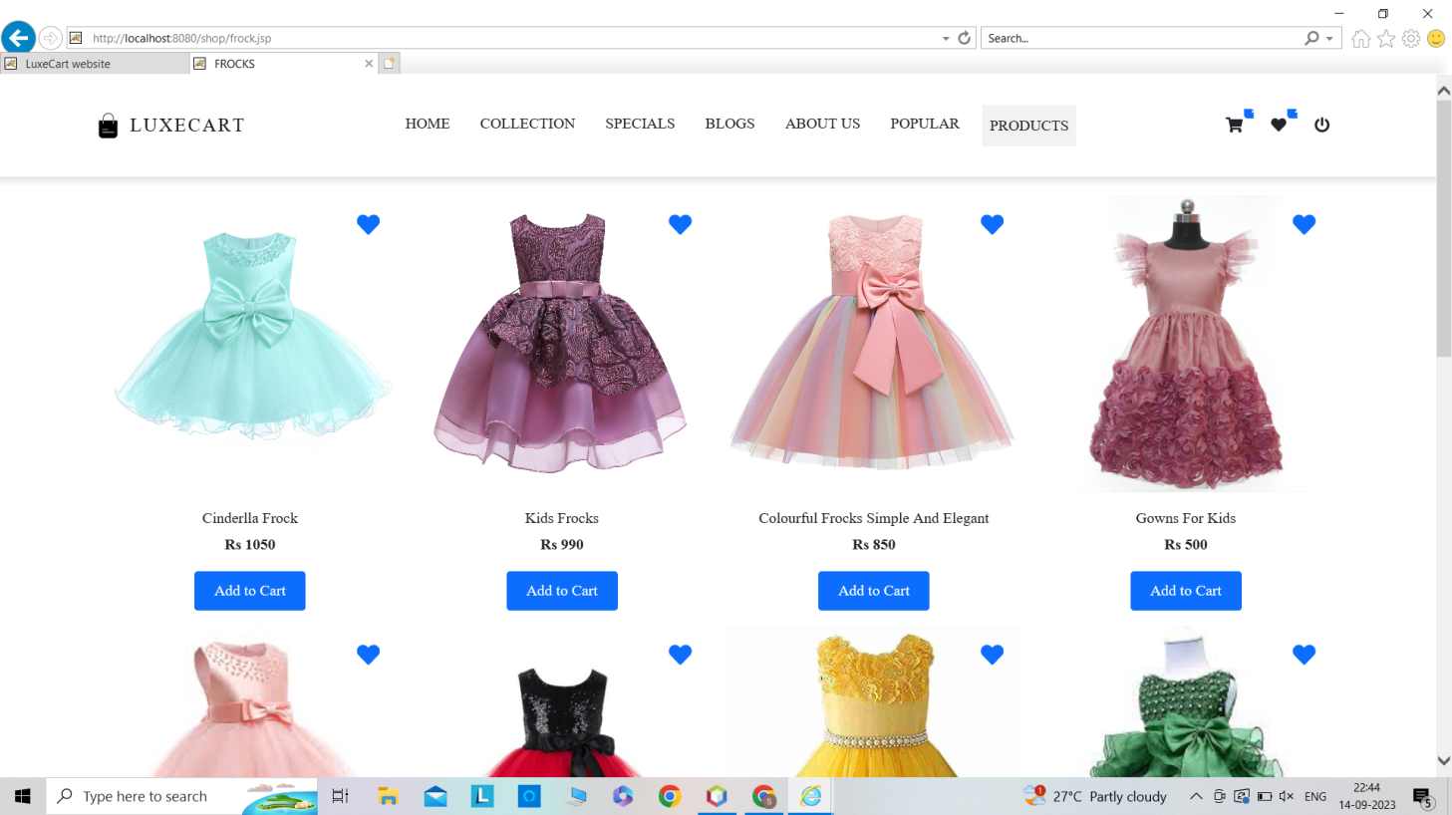

**Shoes :**

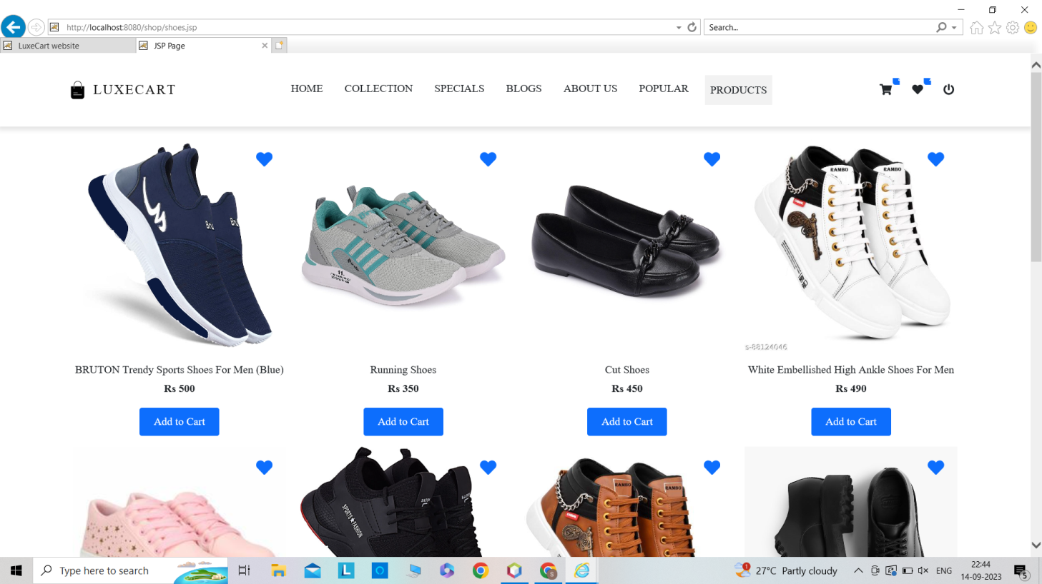

**Toys :**

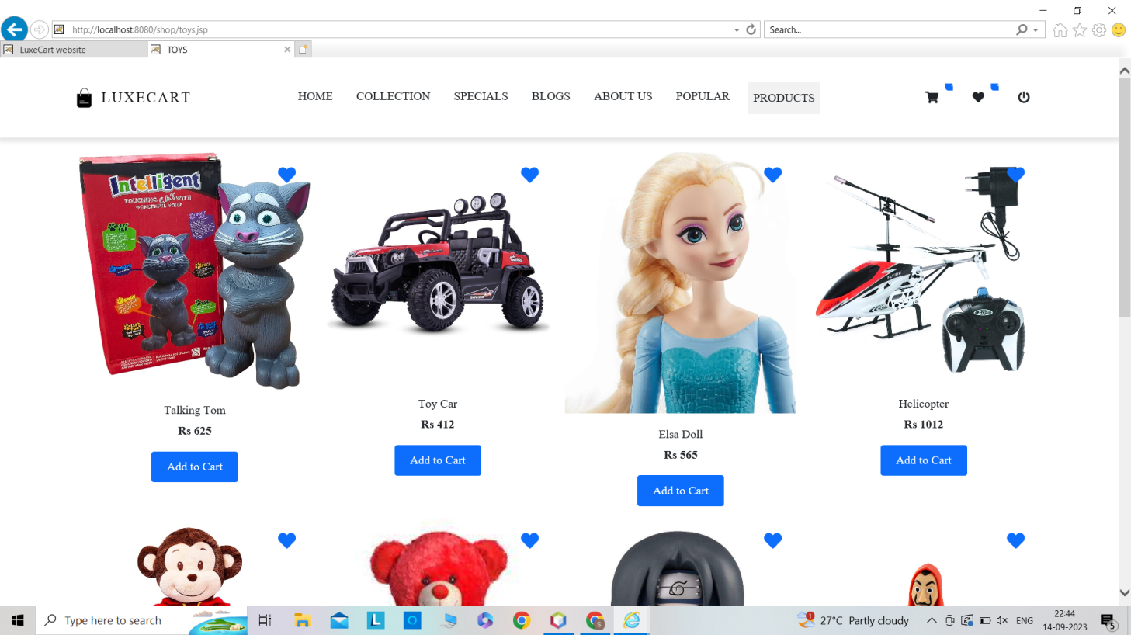

**Cart:**

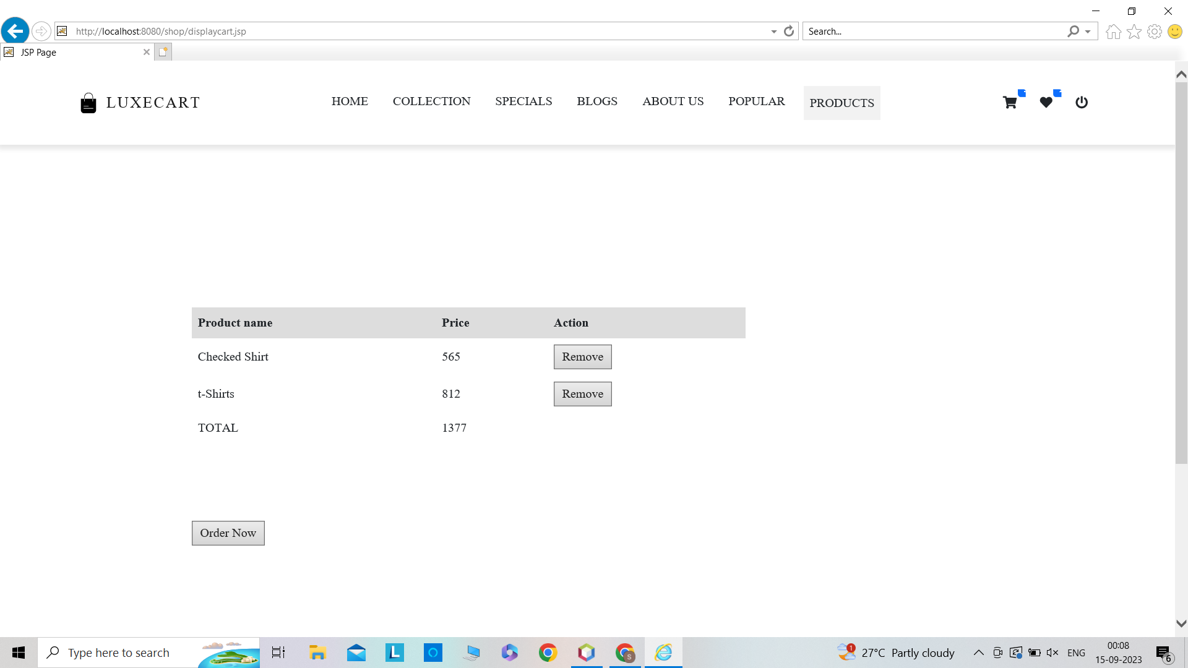

**Order Status :**

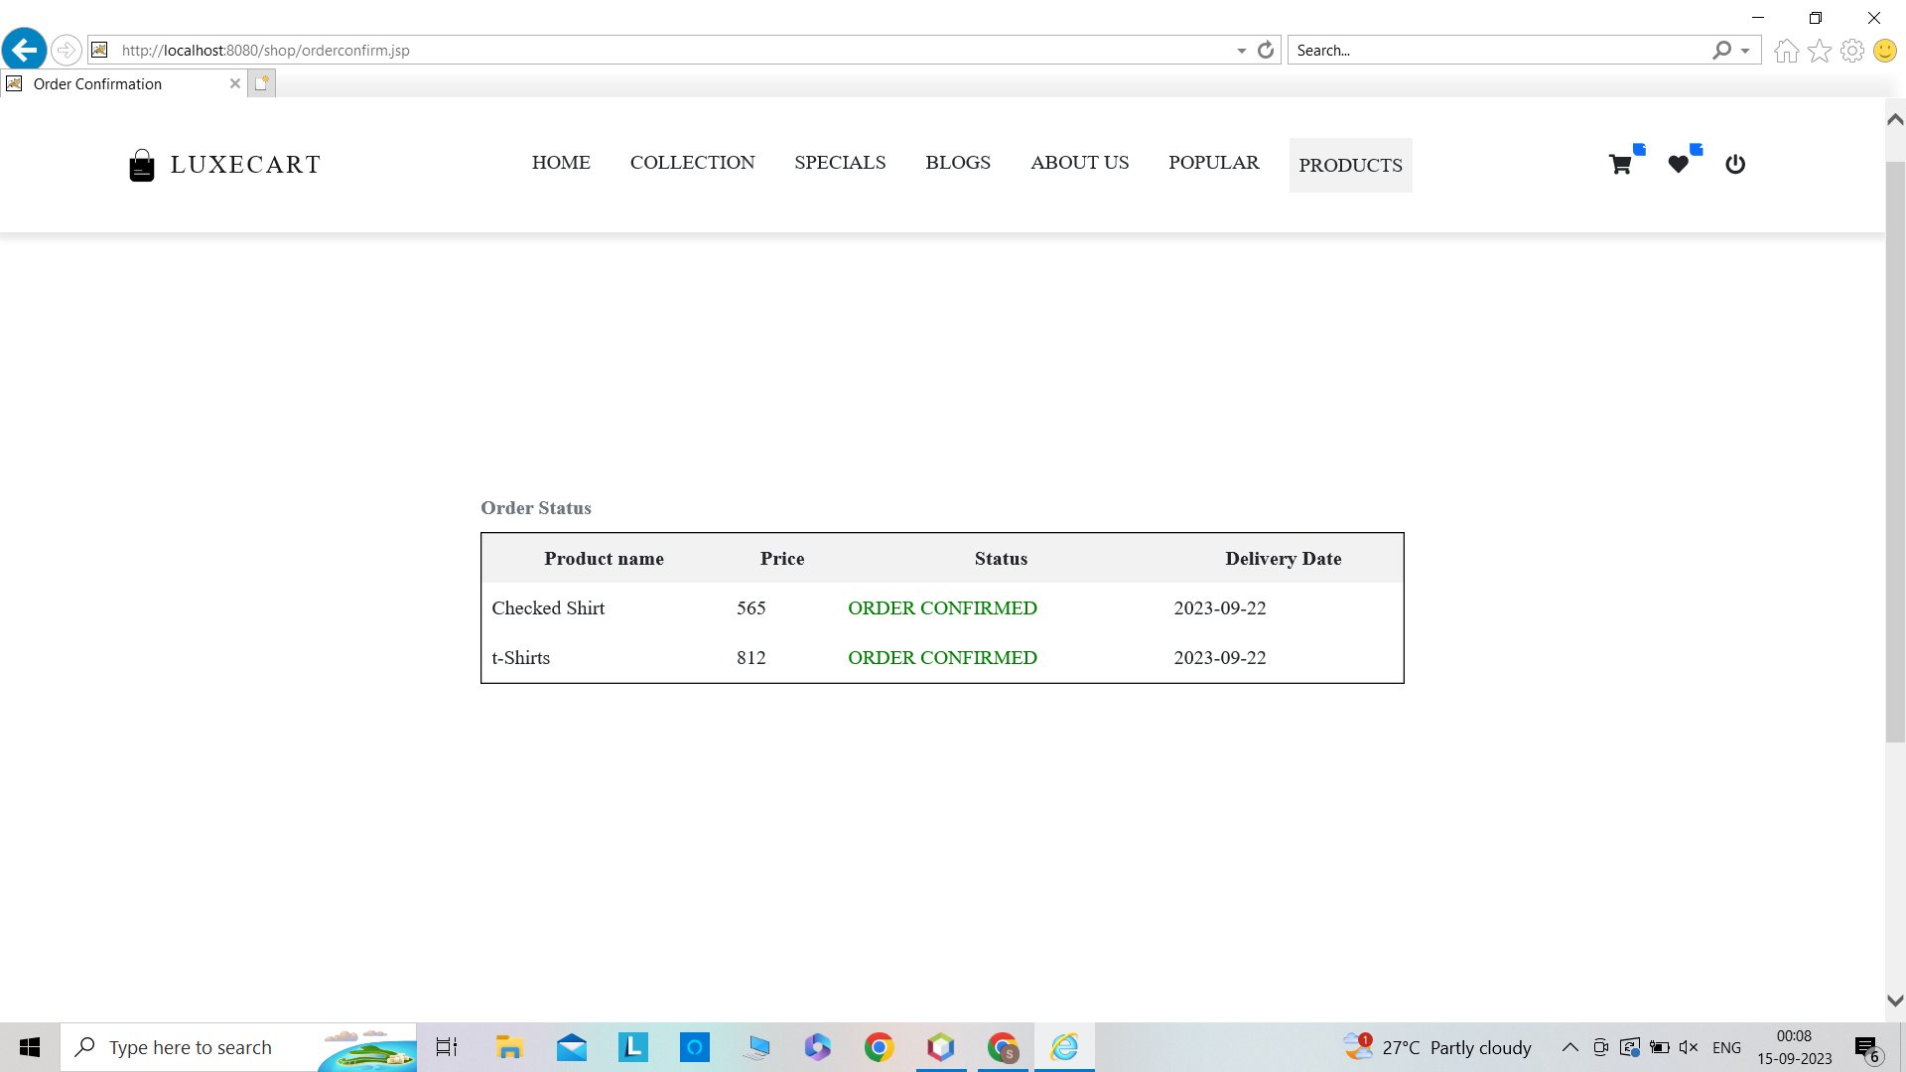

**SOURCE CODE**

**Login.jsp :**

<%@ page import="java.sql.*" %>

<%@ page language="java" %>

<%@ page contentType="text/html; charset=UTF-8" %>

<!DOCTYPE html>

<html lang="en">

<head>

<meta charset="UTF-8">

<meta name="viewport" content="width=device-width, initial-scale=1.0">

<meta http-equiv="X-UA-Compatible" content="ie=edge">

<title>Sign in </title>

<link rel="stylesheet"

href="fonts/material-icon/css/material-design-iconic-font.min.css">

<link rel="stylesheet" href="css/style.css">

</head>

<body>

<%

String uname=request.getParameter("username");

String upwd=request.getParameter("password");

try {

Class.forName("com.mysql.cj.jdbc.Driver");

Connection conn = DriverManager.getConnection("jdbc:mysql://localhost:3306/pinky?zeroDateTimeBehavior=CONVERT_TO_NULL", "root", "Selvarani@123");

Statement st=conn.createStatement();

ResultSet rs=st.executeQuery("select * from user;");

int a=0;

while(rs.next()){

if(rs.getString("uname").equals(uname) && rs.getString("upwd").equals(upwd))

{ session.setAttribute("myData",uname);

RequestDispatcher d=request.getRequestDispatcher("index.jsp");

d.forward(request,response);

}

}

if(a==0)

{

%>

<jsp:forward page="loginstatus.jsp"/>

<%

}

st.close();

conn.close();

}

catch(Exception e)

{

e.getMessage();

}

%>

</body>

</html>

**Reg.jsp :**

<%@ page import="java.sql.*" %>

<%@ page language="java" %>

<%@page contentType="text/html" pageEncoding="UTF-8"%>

<!DOCTYPE html>

<html lang="en">

<head>

<meta charset="UTF-8">

<meta name="viewport" content="width=device-width, initial-scale=1.0">

<title>Login Result</title>

</head>

<body>

<%

//response.setContentType("text/html");

//PrintWriter out =response.getWriter();

/* out.print(uname);*/

String uname=request.getParameter("name");

String uemail=request.getParameter("email");

String upwd=request.getParameter("pass");

String umobile=request.getParameter("contact");

try{

Class.forName("com.mysql.cj.jdbc.Driver");

Connection con =DriverManager.getConnection("jdbc:mysql://localhost:3306/pinky?zeroDateTimeBehavior=CONVERT_TO_NULL","root","Selvarani@123");

Statement st=con.createStatement();

int rs = st.executeUpdate("insert into user values('"+uname+"','"+upwd+"','"+umobile+"','"+uemail+"');");

String sql="create table "+uname+"(" +"pname varchar(20)"+",price int "+",del_date DATE)";

int f=st.executeUpdate(sql);

String datatoforward=uname;

request.setAttribute("myData",datatoforward);

String targetpage="index.html";

session.setAttribute("datafromcurrentjsp",uname.toUpperCase());

request.getRequestDispatcher(targetpage).forward(request,response);

st.close();

con.close();

}catch(Exception e){}

%>

</body>

</html>

**DisplayCart.jsp :**

<%@ page import="java.sql.*" %>

<%@ page language="java" %>

<%@page contentType="text/html" pageEncoding="UTF-8"%>

<!DOCTYPE html>

<html>

<head>

<style>

.center {

display: flex

justify-content: center;

align-items: center;

height: 100vh; /* Center vertically within the viewport */

}

/* CSS for the container */

.table-container {

/* background-color: #f0f0f0; /* Background color for the container */

padding: 20px; /* Add some padding to the container */

border-radius: 10px;

width: 70%;

margin-right: 10%;

margin-left: 10%

/* Adjust the maximum height as needed */

/* Rounded corners for the container */

}

/* CSS to style the table */

table {

border-collapse: collapse; /* Remove borders between table cells */

width: 70%;

margin-top: 200px;

margin-bottom: 100px;/* Table takes 100% width of the container */

}

th, td {

padding: 8px; /* Add padding to table cells */

text-align: left; /* Align text to the left within cells */

}

th {

background-color: #ddd; /* Background color for table headers */

}

</style>

</head>

<body>

<jsp:include page="header.jsp" />

<div class="center">

<div class="table-container">

<table>

<tr>

<th>Product name</th>

<th>Price</th>

<th>Action</th> <!-- New column for the remove button -->

</tr>

<%

String tn = (String) session.getAttribute("myData");

try {

Class.forName("com.mysql.cj.jdbc.Driver");

Connection con = DriverManager.getConnection("jdbc:mysql://localhost:3306/pinky?zeroDateTimeBehavior=CONVERT_TO_NULL", "root", "Selvarani@123");

Statement st = con.createStatement();

String sql = "select * from " + tn;

ResultSet rs = st.executeQuery(sql);

int sum = 0;

while (rs.next()) {

String n = rs.getString("pname");

int p = rs.getInt("price");

sum += p;

%>

<tr>

<td><%= n %></td>

<td><%= p %></td>

<td>

<form action="removeProduct.jsp" method="post">

<input type="hidden" name="productName" value="<%= n %>">

<input type="hidden" name="pprice" value="<%= p %>">

<input type="submit" value="Remove">

</form>

</td>

</tr>

<%

}

%>

<tr>

<td>TOTAL</td>

<td><%= sum %></td>

<td></td> <!-- Empty cell in the last row -->

</tr>

</table>

<form action="orderconfirm.jsp" method="post">

<input type="submit" value="Order Now">

</form>

<%

rs.close();

st.close();

con.close();

} catch (Exception e) {

out.println("Error: " + e.getMessage());

}

%>

</div>

</div>

<jsp:include page="footer.jsp" />

</body>

</html>

**Addtocart.jsp :**

<%@ page import="java.sql.*" %>

<%@ page language="java" %>

<%@page contentType="text/html" pageEncoding="UTF-8"%>

<!DOCTYPE html>

<html>

<head>

<meta http-equiv="Content-Type" content="text/html; charset=UTF-8">

<title>Cart status</title>

<style>

/* CSS for centering elements */

.center {

display: flex;

flex-direction: column;

justify-content: center;

align-items: center;

min-height: 100vh;

}

</style>

</head>

<body>

<jsp:include page="header.jsp" />

<%

String tn=(String) session.getAttribute("myData");

String pn=request.getParameter("name");

int pri=Integer.parseInt(request.getParameter("price"));

try{

Class.forName("com.mysql.cj.jdbc.Driver");

Connection con =DriverManager.getConnection("jdbc:mysql://localhost:3306/pinky?zeroDateTimeBehavior=CONVERT_TO_NULL","root","Selvarani@123");

Statement st=con.createStatement();

String sql="insert into "+tn+" values('"+pn+"',"+pri+")";

int rs=st.executeUpdate(sql);

st.close();

con.close();

response.sendRedirect("displaycart.jsp");

}

catch(Exception e)

{

out.println("Error: "+e.getMessage());

}

%>

</body>

<jsp:include page="footer.jsp" />

</html>

**Removeproduct.jsp**

<%@page contentType="text/html" pageEncoding="UTF-8"%>

<%@ page import="java.sql.Connection, java.sql.DriverManager, java.sql.PreparedStatement" %>

<!DOCTYPE html>

<html>

<head>

<meta http-equiv="Content-Type" content="text/html; charset=UTF-8">

<title>JSP Page</title>

</head>

<body>

<%

// Get the product name from the form

String productName = request.getParameter("productName");

int price = Integer.parseInt(request.getParameter("pprice"));

String tn = (String) session.getAttribute("myData");

try {

// Define the database connection details

String jdbcUrl = "jdbc:mysql://localhost:3306/pinky?zeroDateTimeBehavior=CONVERT_TO_NULL";

String dbUsername = "root";

String dbPassword = "Selvarani@123";

// Load the MySQL JDBC driver

Class.forName("com.mysql.cj.jdbc.Driver");

// Establish a database connection

Connection connection = DriverManager.getConnection(jdbcUrl, dbUsername, dbPassword);

// Define the SQL query to delete the row with the specified product name

String sql = "DELETE FROM "+tn+" WHERE pname = ? and price=?";

// Create a PreparedStatement

PreparedStatement preparedStatement = connection.prepareStatement(sql);

// Set the parameter value (product name)

preparedStatement.setString(1, productName);

preparedStatement.setInt(2, price);

// Execute the SQL query to delete the row

int rowsAffected = preparedStatement.executeUpdate();

// Close the resources

preparedStatement.close();

connection.close();

// Check if the row was deleted successfully

if(rowsAffected>0){

response.sendRedirect("displaycart.jsp");

}

} catch (Exception e) {

out.println("Error: " + e.getMessage());

}

%>

</body>

</html>

Productsample code :

**Orderconfirm.jsp :**

<%@page contentType="text/html" pageEncoding="UTF-8"%>

<%@ page import="java.sql.Connection, java.sql.DriverManager, java.sql.Statement, java.sql.ResultSet" %>

<%@ page import="java.sql.Connection, java.sql.DriverManager, java.sql.PreparedStatement, java.sql.ResultSet" %>

<%@ page import="java.util.Calendar" %>

<!DOCTYPE html>

<html lang="en">

<head>

<meta charset="UTF-8">

<meta name="viewport" content="width=device-width, initial-scale=1.0">

<title>Order Confirmation</title>

<style>

table {

width: 70%;

border-collapse: collapse;

caption-side: top;

}

table, th, td {

border: 1px solid black;

}

.table-container {

text-align: center;

width: 70%/* Center-align the table and caption */

}

table {

margin: 0 auto; /* Center-align the table within the container */

border-collapse: collapse;

}

caption {

caption-side: top; /* Display the caption above the table */

font-weight: bold;

}

th, td {

max-width: 150px; /* Adjust the maximum width as needed */

overflow: hidden;

white-space: nowrap;

text-overflow: ellipsis;

}

th, td {

padding: 8px;

text-align: left;

}

.center {

display: flex;

justify-content: center;

align-items: center;

height: 100vh; /* Center vertically within the viewport */

}

th {

background-color: #f2f2f2;

}

/* .table-container {padding: 20px; /* Add some padding to the container */

/* border-radius: 10px;*/

/* width: 70%;*/

/* margin-right: 10%;*/

/* margin-left: 10%}*/

.ordered {

color: green;

}

.table-container-centered {

text-align: center;

position: relative;

z-index: 1; /* Adjust the z-index value as needed */

}

</style>

</head>

<body>

<jsp:include page="header.jsp" />

<h1>Order Confirmation</h1>

<div class="center">

<div class="table-container">

<%

String tn = (String) session.getAttribute("myData");

Calendar calendar = Calendar.getInstance();

calendar.add(Calendar.DAY_OF_YEAR, 7);

java.sql.Date deliveryDate = new java.sql.Date(calendar.getTime().getTime());

try {

Class.forName("com.mysql.cj.jdbc.Driver");

Connection con = DriverManager.getConnection("jdbc:mysql://localhost:3306/pinky?zeroDateTimeBehavior=CONVER T_TO_NULL", "root", "Selvarani@123");

// Update the delivery date for all rows in the table

PreparedStatement preparedStatement = con.prepareStatement("UPDATE " + tn + " SET del_date = ?");

preparedStatement.setDate(1, deliveryDate);

int rowsAffected = preparedStatement.executeUpdate();

preparedStatement.close();

if (rowsAffected > 0) {

// Delivery dates were successfully updated

// Display the table with the updated delivery dates

Statement st = con.createStatement();

String sql = "SELECT pname, price, del_date FROM " + tn;

ResultSet rs = st.executeQuery(sql);

%>

<table>

<caption class="caption">Order Status</caption>

<tr>

<th>Product name</th>

<th>Price</th>

<th>Status</th>

<th>Delivery Date</th> <!-- 4th column for delivery date -->

</tr>

<%

while (rs.next()) {

String n = rs.getString("pname");

int p = rs.getInt("price");

java.sql.Date delDate = rs.getDate("del_date");

%>

<tr>

<td><%= n %></td>

<td><%= p %></td>

<td class="ordered">ORDER CONFIRMED</td>

<td><%= delDate %></td> <!-- Display the delivery date -->

</tr>

<%

}

rs.close();

st.close();

%>

</table>

<%

} else {

// No rows were updated

out.println("No rows were updated with delivery dates.");

}

con.close();

} catch (Exception e) {

out.println("Error: " + e.getMessage());

}

%>

</div>

</div>

<jsp:include page="footer.jsp" />

</body>

</html>

**CONCLUSION**

The project entitled **Online shopping system** was completed successfully.The system has been developed with much care and free of errors and at the same time it is efficient and less time consuming. The purpose of this project was to develop a web application and an android application for purchasing items from a shop.

This project helped us in gaining valuable information and practical knowledge on several topics like designing web pages using html & css, usage of responsive templates, designing of android applications, and management of databases using mysql . The entire system is secured. Also the project helped us understand about the development phases of a project and software development life cycle. We learned how to test different features of a project.

This project has given us great satisfaction in having designed an application which can be implemented to any nearby shops or branded shops selling various kinds of products by simple modifications.

There is a scope for further development in our project to a great extent. A number of features can be added to this system in future like providing moderators more control over products so that each moderator can maintain their own products. Another feature we wished to implement was providing classes for customers so that different offers can be given to each class. System may keep track of the history of purchases of each customer and provide suggestions based on their history. These features could have been implemented unless time did not limit us.

**REFERENCES**

**[1]** [**https://www.w3schools.in/jsp/tutorials/**](https://www.w3schools.in/jsp/tutorials/)

**[2]** [**https://www.geeksforgeeks.org/introduction-to-jdbc/**](https://www.geeksforgeeks.org/introduction-to-jdbc/)

**[3]** Mcgraw Hill's , Java : The complete reference 7thEdition, Herbert Schildit